Table 1 NMR-Resonance assignments for Art-Est
Residue | NH | Cα | Cβ | Other
1 Ala | 8.196 | 4.568 | 1.368
2 Pro |  | 4.510 | 2.332 | HG1 2.041, HG2 1.990, HD1 3.832, HD2 3.643
3 Leu | 8.311 | 4.422 | 1.542, 1.612 | HG 1.664, HD1 0.948, HD2 0.901
4 Glu | 8.406 | 3.291 | 1.845, 1.717 | HG 2.140
5 Pro |  | 4.404 | 2.364, 1.926 | HD1 3.415, HD2 3.097, HG 1.746
6 Glu | 8.658 | 4.266 | 1.915 | HG 2.378
7 Tyr | 8.810 | 3.975 | 2.712, 2.964 | HD 6.788, HE 6.658
8 Pro |  |  | 1.327, 1.551 | HD1 2.502, HD2 3.104, HG 1.755
9 Gly |  | 4.375, 3.477
10 Asp | 8.631 | 4.452 | 2.577, 2.815
11 Asn | 8.386 | 4.885 | 2.733, 2.905 | HD21 7.584, HD22 6.928
12 Ala | 7.043 | 4.244 | 1.226
13 Thr | 8.507 | 4.608 | 4.815 | HG2 1.404
14 Pro |  | 4.293 | 2.428 | HG1 2.045, HG2 2.306, HD 3.984
15 Glu | 8.693 | 4.181
16 Gln | 7.898 | 4.110
17 Met | 8.662 | 4.566 |  | HE 1.977
18 His | 8.803 | 4.465 | 3.388 | HD2 7.234, HE1 8.512
19 Gln | 8.189 | 4.211 | 2.260 | HG 2.548
20 Tyr | 8.257 | 4.501 | 3.227 | HD 7.147, HE 6.641
21 Ala | 8.588 | 3.789 | 1.645
22 His | 8.004 | 4.331 | 3.342 | HD2 7.139, HE1 8.285
23 Gln | 8.518 | 4.072
24 Leu | 8.991 | 3.994
25 Arg | 7.997 | 3.951
26 Arg | 7.642 | 4.053
27 Tyr | 8.057 | 4.258 | 3.174, 3.305 | HD 7.009, HE 6.675
28 Ile | 8.355 | 3.528
29 Asn | 7.920 | 4.488 | 2.862, 2.921 | HD21 6.904, HD22 7.592
30 Met | 7.923 | 4.273
31 Leu | 7.585 | 4.017

Table 2 Kinetic parameters for the hydrolysis of p-nitrophenyl esters by Art-Est.ª
Catalyst | pH | Substrate^{b} | k₂ / M⁻¹ s⁻¹
Art-Est | 3.6 | pNPF | 5.4 x 10⁻³
Art-Est | 4.1 | pNPF | 9.4 x 10⁻³
Art-Est | 4.6 | pNPF | 1.2 x 10⁻²
Art-Est | 5.1 | pNPF | 1.7 x 10⁻²
Art-Est | 5.6 | pNPF | 3.6 x 10⁻²
Art-Est | 6.1 | pNPF | 4.8 x 10⁻²
Art-Est | 6.6 | pNPF | 5.0 x 10⁻²
Art-Est | 7.1 | pNPF | 4.6 x 10⁻²
Art-Est | 7.35 | pNPF | 3.6 x 10⁻²
Art-Est | 7.6 | pNPF | 2.4 x 10⁻²
Art-Est | 7.9 | pNPF | 2.5 x 10⁻²
Art-Est | 5.1 | pNPA | 1.4 x 10⁻²
Art-Est  (10% TFE) | 5.1 | pNPA | 1.0 x 10⁻²

ª Reactions were performed in 100 mM buffer (acetate pH 5.1 and below; MES for 5.6 < pH >6.1; MOPS above pH 6.6) at 290 K; ^{b} substrates used were mono-p-nitrophenyl fumarate (pNPF) or acetate (pNPA).

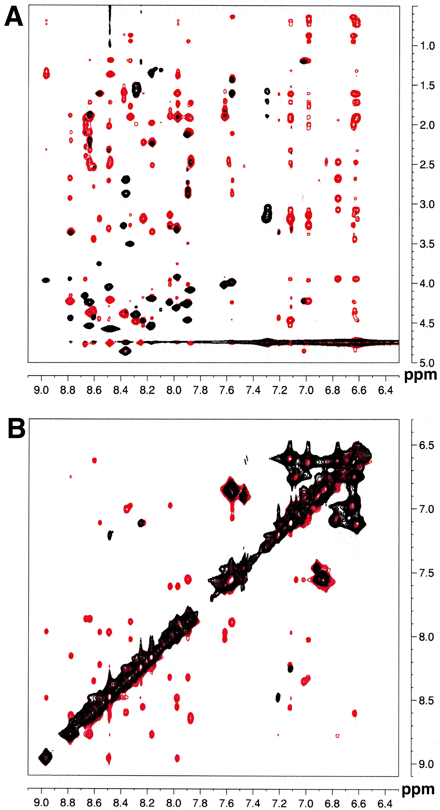
Figure 1. Overlays of TOCSY (black) and NOESY (red) spectra of Art-Est (6 mM, pH 5.4).

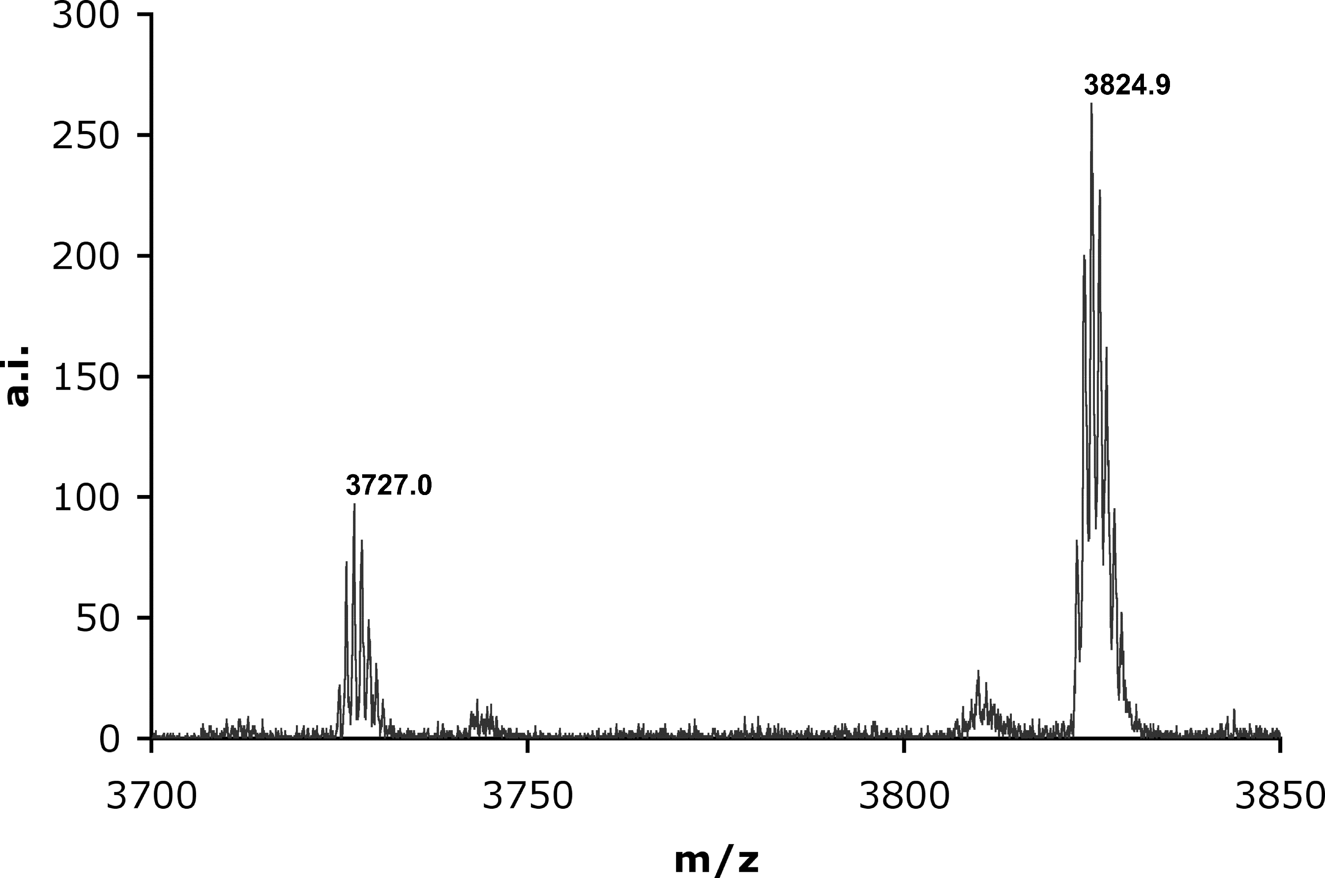
Figure 2 MALDI-TOF mass spectrum of fumaryl-Art-Est isolated by C18 reversed phase HPLC from a reaction of Art-Est with mono-p-nitrophenyl-fumarate. The small amount of free Art-Est is generated during work-up of the acidic solution of the peptide. The mass difference of 98 mass units corresponds to the fumaryl group.

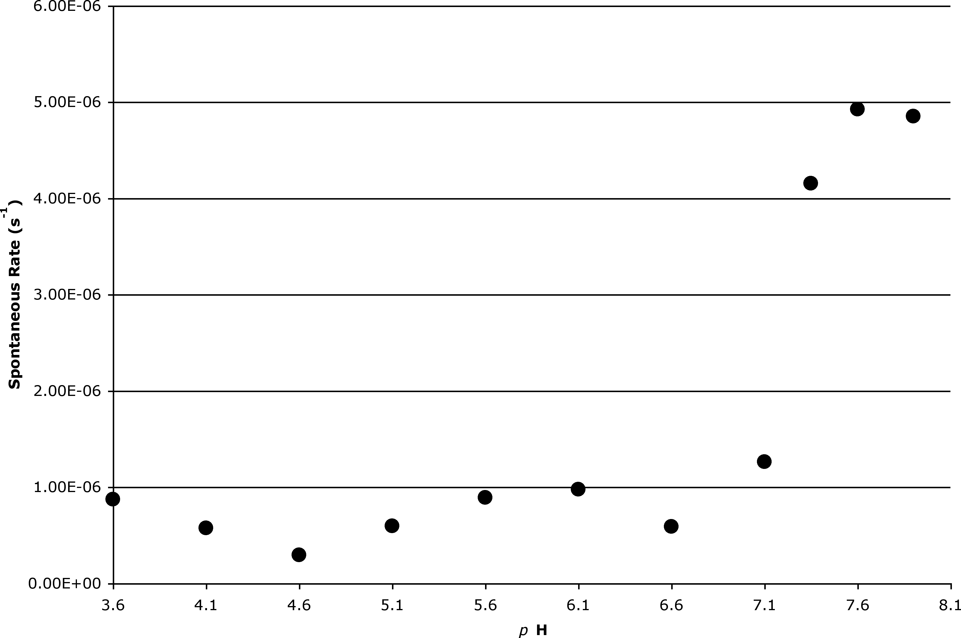
Figure 3 Rates for the hydrolysis of mono-p-nitrophenyl fumarate (91 µM) as a function of the pH using conditions identical to those reported in Fig. 7A of the main manuscript but omitting Art-Est. Note the rate increase around the pK_{a} of p-nitrophenol (7.15).

